**Every client who want to use Help Services , first They have to add N-K-1 AsiHelpClientId and AsiHelpServices (As shown in Below Screen shot).**

Screen Shot of Asi Help Client ID : -

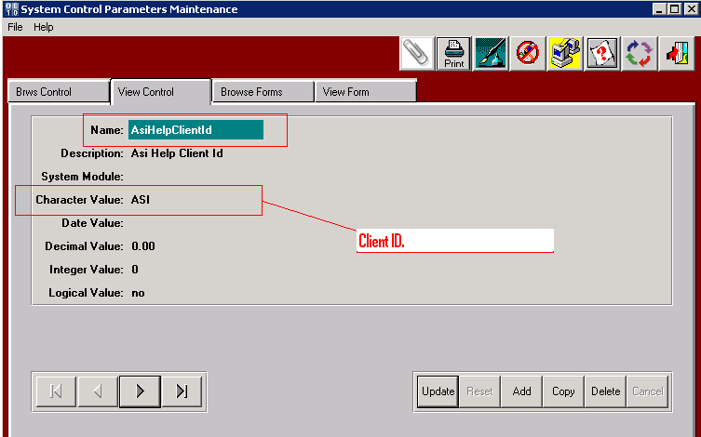

Screen Shot of Asi Help Services :-

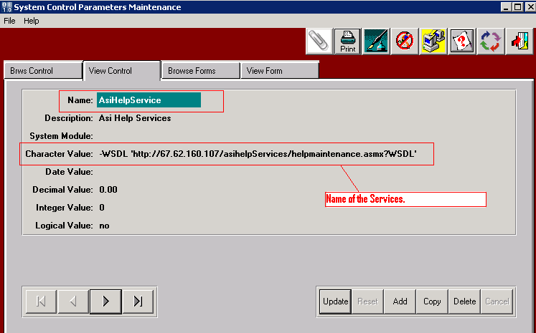

**Below Screen Shot Shows, How a Client can use the Help Services**.

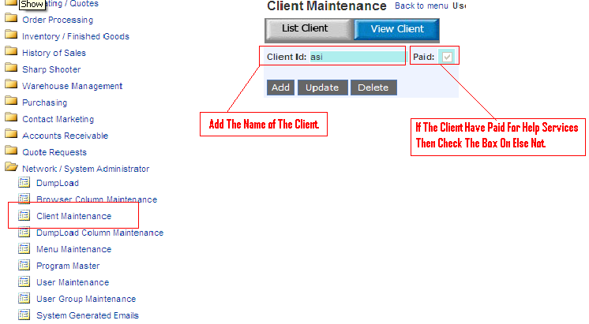

**Files Needs to Transfer on Clients : -**

1. Sys/ref/hlp-ctrl.r
2. Sys/ref/hlp.r
3. Sys/ref/hlpd.r
4. Sys/ref/hlpupd.r
5. Sys/ref/hlpupd2.r.